Discriminator projection:

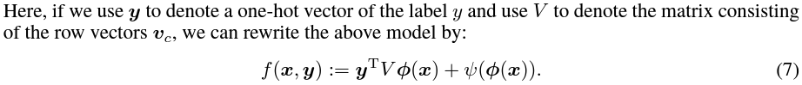

Conditional Batch Normalization:

Hinge Loss:

[Tips for Training Stable Generative Adversarial Networks - MachineLearningMastery.com](https://machinelearningmastery.com/how-to-train-stable-generative-adversarial-networks/)